Assignment 2:

To create Todo list:

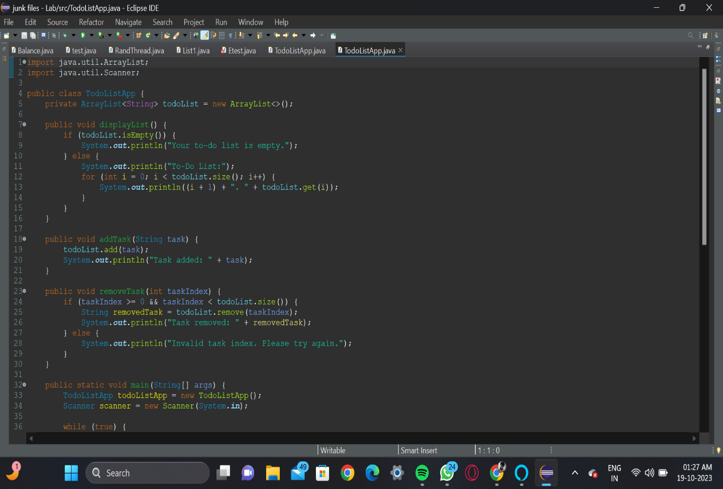

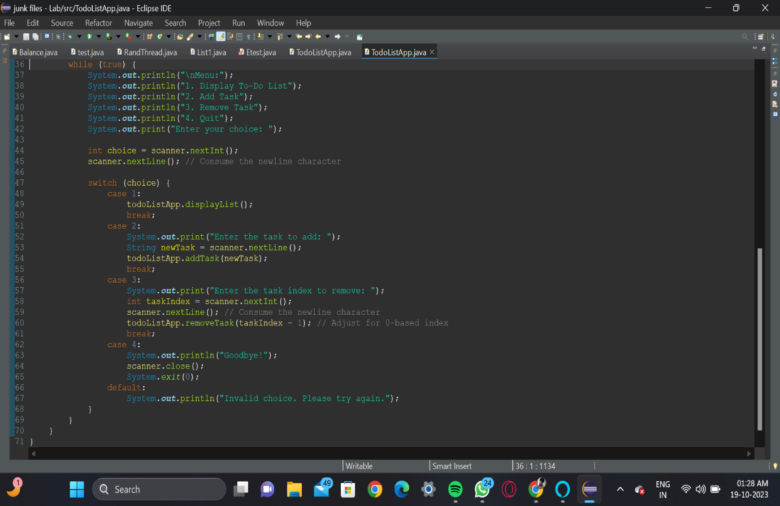

In above code I have followed 4 steps successfully:

* Step 1: Set Up Your Project

- Create a new Java class, let's call it TodoListApp.

- Import the necessary libraries, including java.util.ArrayList and java.util.Scanner.

* Step 2: Define Data Structures

- Create an ArrayList to store tasks.

Snippet:

import java.util.ArrayList;

public class TodoListApp

{

private ArrayList<String> todoList = new ArrayList<>();

}

* Step 3: Define Functions

- Implement the following functions:

- displayList(): Iterate through todoList and print out each task along with its index.

- addTask(String task): Use the add() method of ArrayList to add the task to todoList.

- removeTask(int taskIndex): Check if taskIndex is valid and use the remove() method to remove the task at the specified index.

* Step 4: Implement the Main Function

- Initialize the to-do list by creating an instance of TodoListApp.

- Use a loop (e.g., while) to continuously display the menu until the user chooses to quit.

- Handle user input using java.util.Scanner.

- Execute the corresponding function based on the user's choice (display, add, or remove).

* Step 5: Testing

- Test the displayList function by calling it in your main method.

- Test the addTask function by adding sample tasks and checking if they are added to the list.

- Test the removeTask function by calling it with a sample task index and checking if the task is removed correctly.

Output:

